|  |
| --- |
|  |
| Capstone Project Document |

**WingS**

Report #6 – User Guide

|  |  |  |
| --- | --- | --- |
| **WingS** | | |
| **Group Members** | Đào Trọng Nghĩa | SE03220 |
| Lê Hồng Nhiên | SE03377 |
| Tạ Ngọc Duy | SE03267 |
| Đỗ Văn Tuấn | SE03297 |
| Hoàng Tuấn Anh | SE03108 |
| **Supervisor** | Mr. Nguyễn Văn Sang | |
| **Project code** | WS | |

**- Hanoi, 10/12/2016 -**

# SIGNATURE PAGE

AUTHOR: Đỗ Văn Tuấn 10/12/2016

Team member

REVIEWERS: Đào Trọng Nghĩa 10/12/2016

Project manager

APPROVAL: Nguyễn Văn Sang --/--/2016

Supervisor

Record of change

*A - Added M - Modified D – Deleted

|  |  |  |  |  |  |
| --- | --- | --- | --- | --- | --- |
| Effective Date | Changed Item | A,M,D | Change Description | Reason for Change | Rev. Number |
| 10/Dec/2016 | User guide | A | Add new |  | 1.0 |
|  |  |  |  |  |  |
|  |  |  |  |  |  |
|  |  |  |  |  |  |
|  |  |  |  |  |  |
|  |  |  |  |  |  |
|  |  |  |  |  |  |
|  |  |  |  |  |  |
|  |  |  |  |  |  |
|  |  |  |  |  |  |
|  |  |  |  |  |  |
|  |  |  |  |  |  |
|  |  |  |  |  |  |
|  |  |  |  |  |  |
|  |  |  |  |  |  |
|  |  |  |  |  |  |

Table of Contents

SIGNATURE PAGE 1

1 Introduction 3

2 USER GUIDELINES 3

2.1 Register 3

2.2 Login 4

2.3 Search 5

2.4 Create thread 6

2.5 Thread 7

2.6 Thread detail 8

2.7 Edit thread 9

2.8 Create Event 10

2.9 Event 11

2.10 Event Detail 12

2.11 Edit Event 15

2.12 Create organization 16

2.13 Organization 17

2.14 Organization detail 18

2.15 Edit Organization 21

2.16 Donate Event 22

2.17 Message 23

2.18 Account management 26

2.19 ADMIN 30

# Introduction

This user's manual has been developed to help users better understand the requirements that may apply to use this website by providing them simple step by step tutorials. This manual is intended to help make website's functions more accessible and their associated requirements more understandable to users.

# USER GUIDELINES

## Register

This is the first page which user will see. From this page the user can go to every page they want.

To register account on website, the users do the steps below:

Step 1: Open browser and enter to the address bar: <http://wings.com/>. Homepage is displayed.

Step 2: Click on “ăng nhập -> Đăng ký” button in header. Users will go to Register page.

Step 3: Enter information and click on Đăng ký button or User can register by choose Login with Facebook.

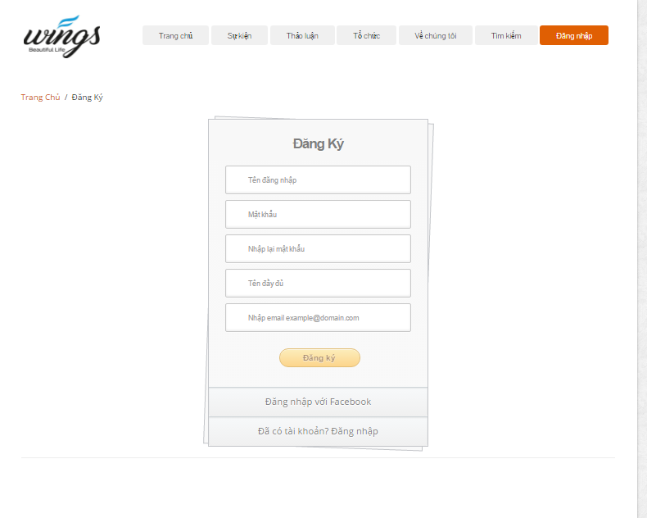

1. R**egister screen**

## Login

To login account on website, the users do the steps below:

Step 1: Open browser and enter to the address bar: <http://wings.com/>. Homepage is displayed.

Step 2: Click on “Đăng nhập” button in header. User will go to Login page.

Step 3: User can choose Login with Facebook.

Step 3: User can choose Login with WS’account:

Step 3.1: User enter username and password

Step 3.2: Click on Login button

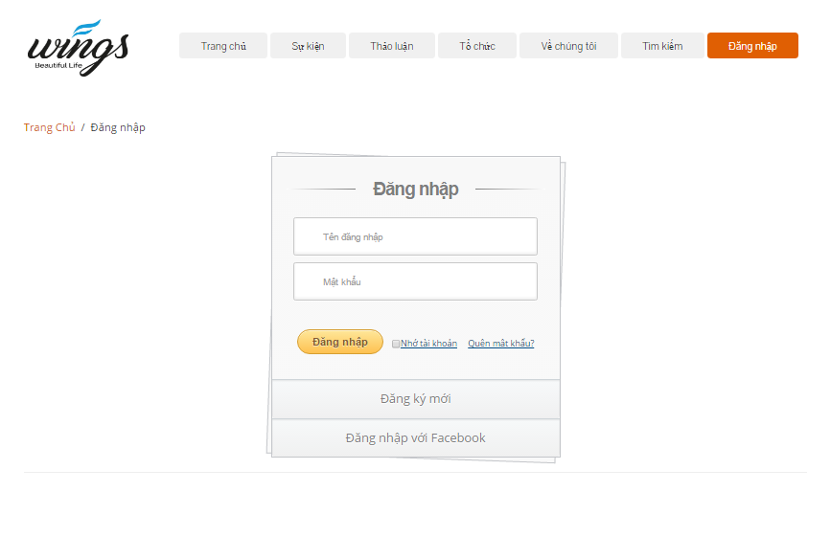

1. Login **page**

## Search

To use search function on website, the users do the steps below:

Step 1: In Home page, click “Tìm kiếm” button in header. User will go to Search page.

Step 2: Choose type search follow: Tài khoản, Cá nhân, Bài viết, Sự kiện, Tổ chức. Enter key word into text filed and click “Tìm kiếm” button or press enter.

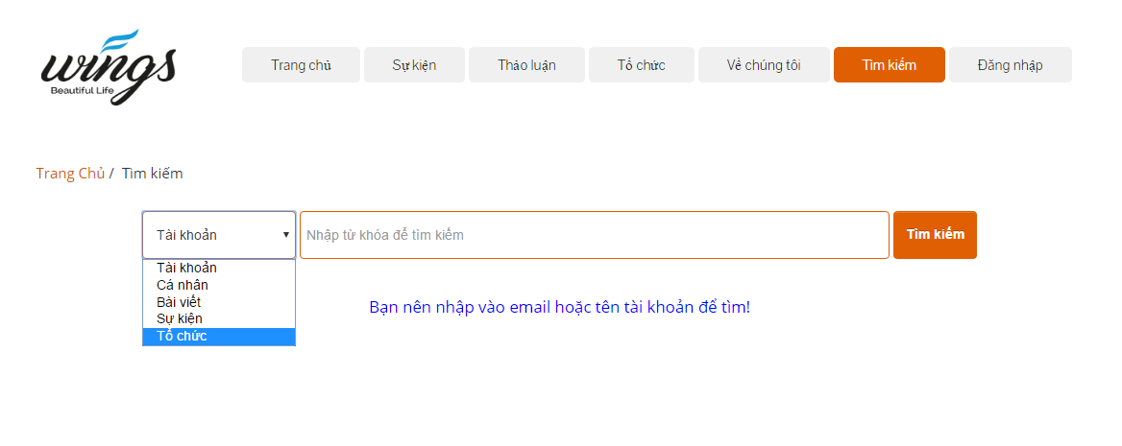

1. Search page

Step3: Search result page is displayed.

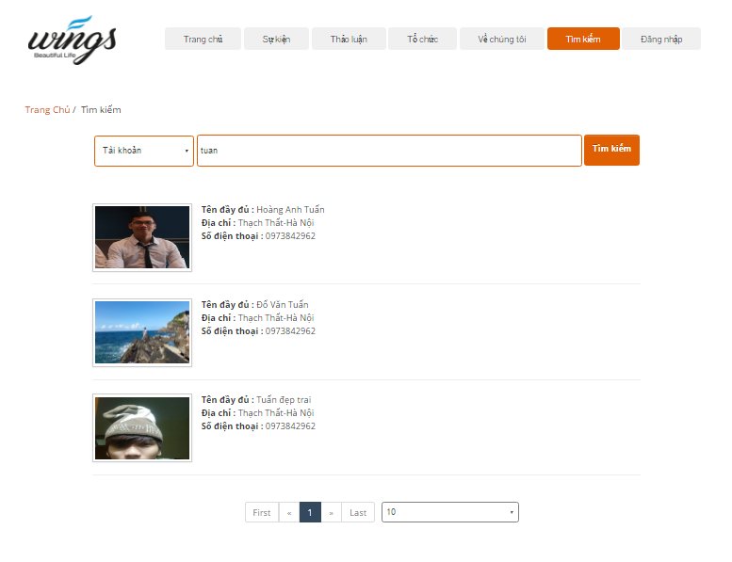

1. Search “Tài khoản” result

## Create thread

In this page, user can create a new thread to discussion…

Go to Create thread page, the user do the steps below:

Step 1: Go to Homepage.

Step 2: Click on “Tạo thảo luận” button. System will go to Create thread page.

Step 3: User enter information

Step 4: Click on “Tạo thảo luận” button.

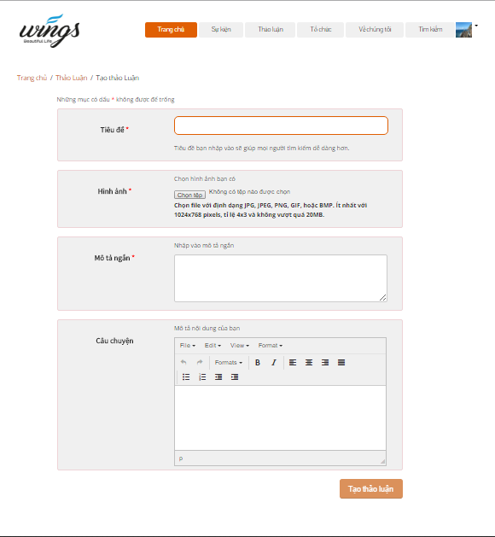

1. Create thread screen

## Thread

In this page, user can view thread list, view number likes, number comments…  
Go to Thread page, the user do the steps below:

Step 1: Go to Homepage.

Step 2: Click on “Thảo luận” button in header

Step 3: Thread page is displayed and allow user can view. Thread list ordered by create date.

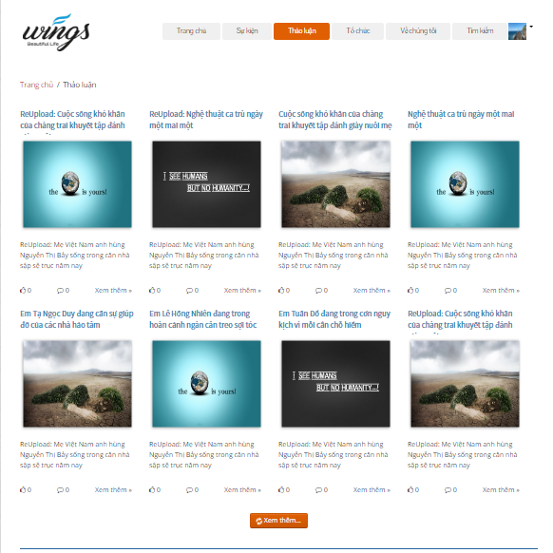

1. Thread page

## Thread detail

In this page user can view details project. And user also can like, share, comment, report.

Go to the Thread detail page, user can click any into image of thread or “Xem thêm” link in thread list.

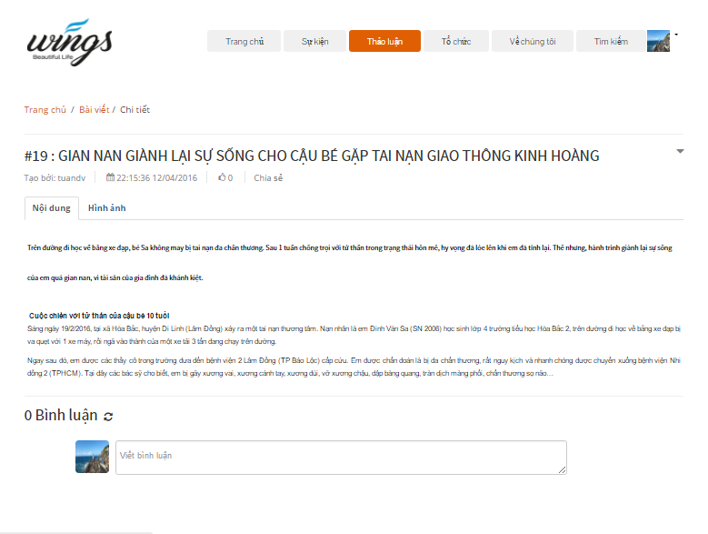

1. Thread detail screen

### Report thread

To sent report about thread user do the step below:

Step 1: Go to thread detail of a thread.

Step 2: Click  in thread detail page. System will display:

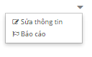

Step 3: Click on “Báo cáo”. Dialog Report will display :

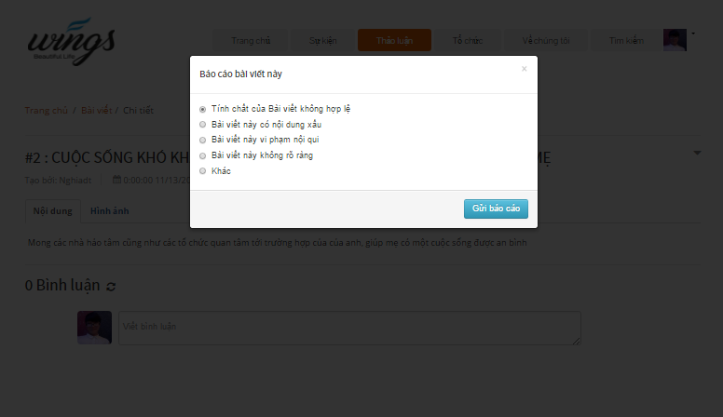

1. Dialog report

Step 4: Choose a reason which you want see and click on “Gửi báo cáo” button.

### Comment thread

User can comment all of things relate about thread

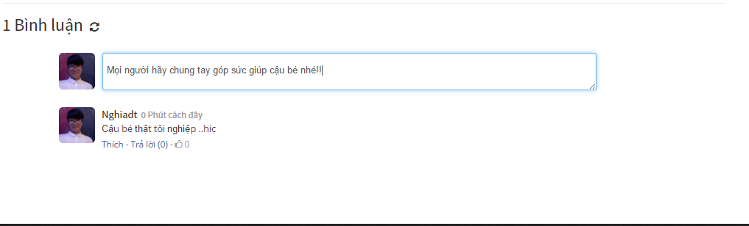

1. Comment screen

## Edit thread

To edit thread user do the step below:

Step 1: Go to thread detail page .

Step 2: Click  in thread detail page. System will display:



Step 3: Click on “Sửa thông tin”. User go to edit thread page.

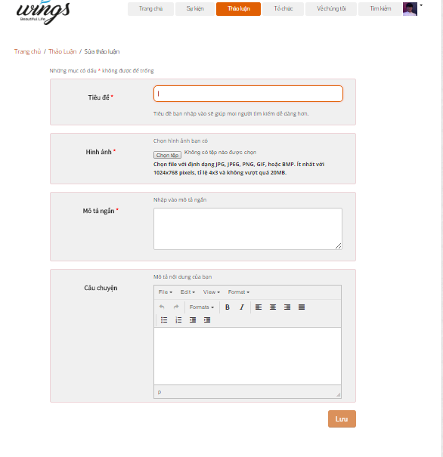

1. Edit thread screen

Step 4: Edit information and click “Lưu” button.

## Create Event

In this page, user can create a new event to raise Donate.

Go to Create event page, the user do the steps below:

Step 1: Go to Homepage.

Step 2: Click on “Tạo sự kiện” button. User will go to Create event page.

Step 3: User enter information

Step 4: Click on “Tạo sự kiện” button.

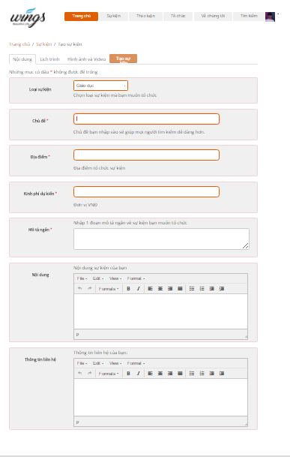

1. Create Event screen

## Event

In this page, user can view event list and filter event by create date, point, type…   
Go to Event page, the user do the steps below:

Step 1: Go to Homepage.

Step 2: Click on “Sự kiện” button in header

Step 3: Event page is displayed and allow user can view.

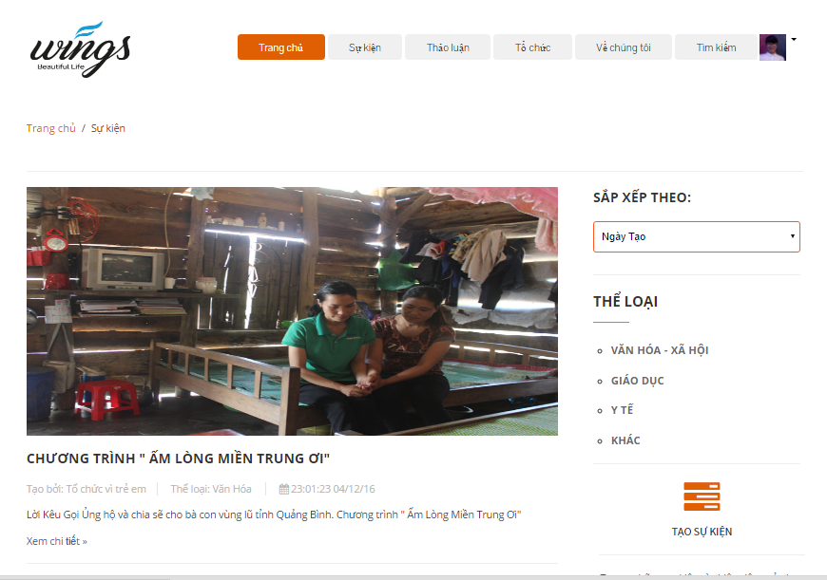

1. Event page screen

## Event Detail

In this page user can view details event. And user also can like, share, comment, report, Donate, Chat room, see video, process of Donate.

Go to the Event detail page, user can click any into image of event or “Xem chi tiết” link in event list.

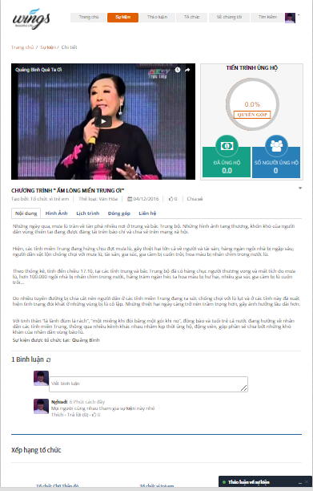

1. Event Detail Screen

### Report event

To send report about event, user do the step below:

Step 1: Go to event detail of a event.

Step 2: Click  in event detail page. System will display:



Step 3: Click on “Báo cáo”. Dialog Report will display :

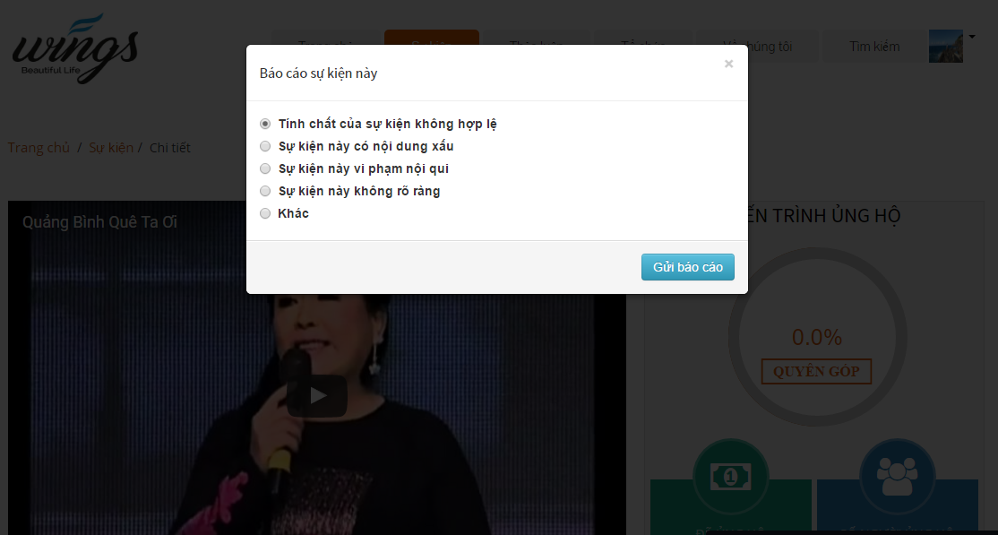

1. Dialog report event

Step 4: Choose a reason which you want see and click on “Gửi báo cáo” button.

### Comment event

User can comment all of things relate about event.



1. Comment event screen

### Chat room

User can chat any thing about event.  
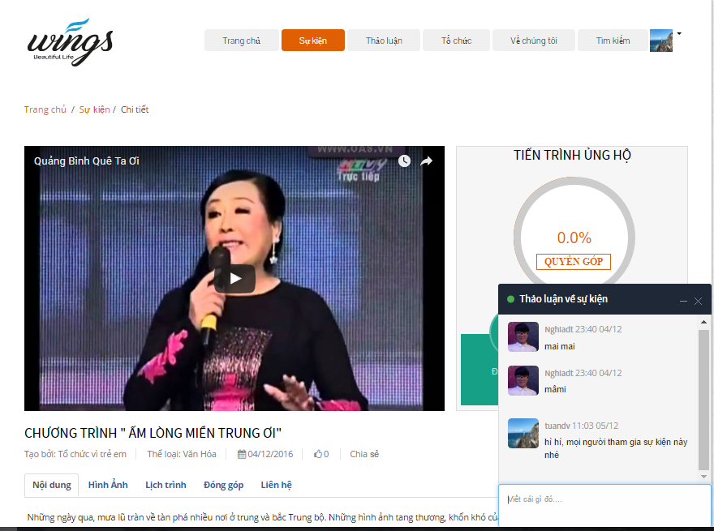

1. Chat room screen

## Edit Event

To edit event user do the step below:

Step 1: Go to event detail page .

Step 2: Click  in event detail page. System will display:



Step 3: Click on “Sửa thông tin”. User go to edit event page.

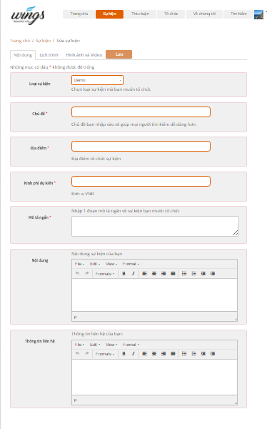

1. Edit Event screen

Step 4: Edit information and click “Lưu” button.

## Create organization

In this page, user can create a new organization to create events.

Go to Create organization page, the user do the steps below:

Step 1: Go to Homepage.

Step 2: Click on “Tạo tổ chức” button. User will go to create organization page.

Step 3: User enter information

Step 4: Click on “Tạo tổ chức” button.

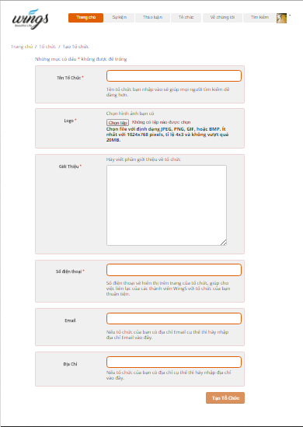

1. Create organization screen

## Organization

In this page, user can view organization list.  
Go to Organization page, the user do the steps below:

Step 1: Go to Homepage.

Step 2: Click on “Tổ chức” button in header

Step 3: Organization page is displayed and allow user can view.

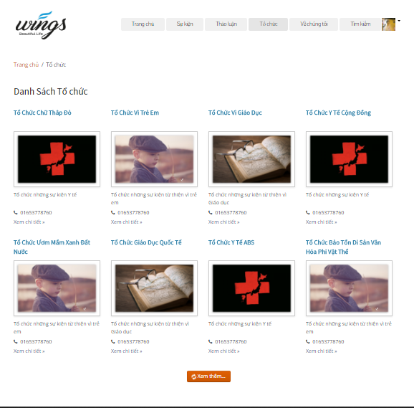

1. Organization screen

## Organization detail

In this page user can view details organization. And user also can inbox, report.

Go to the Organization detail page, user can click any into image of organization or “Xem chi tiết” link in organization list.

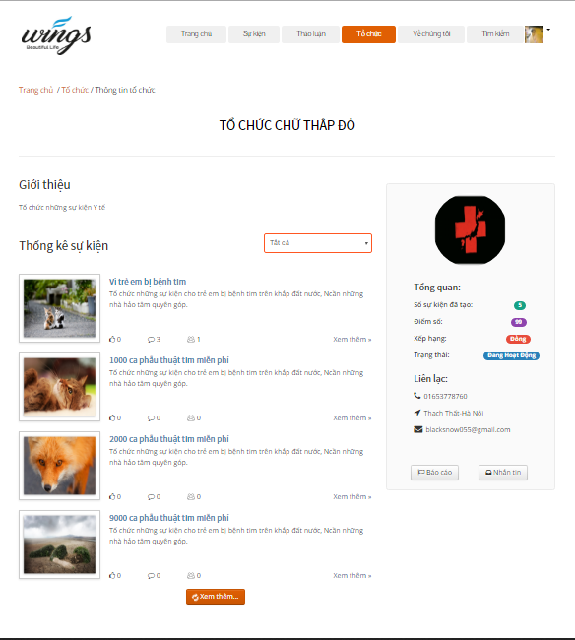

1. Organization detail screen

### Report organization

To send report about organization, user do the step below:

Step 1: Go to organization detail of organization.

Step 2: Click “Báo cáo” button in organization detail page. Dialog Report will display:

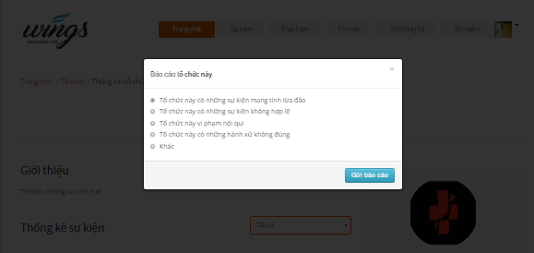

1. Dialog report organization

Step 3: Choose a reason which you want see and click on “Gửi báo cáo” button.

### Send message to Organization

To send message to organization, user do the step below:

Step 1: Go to organization detail of organization.

Step 2: Click “Nhắn tin” button in organization detail page. Dialog Message will display:

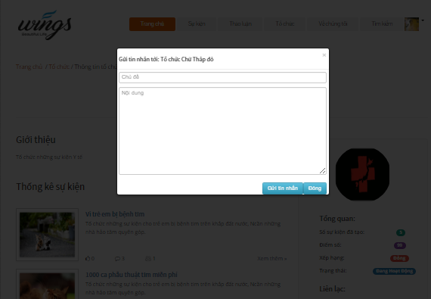

1. Dialog message screen

Step 3: Enter content what you want message to organization, and click “Gửi tin nhắn” button.

## Edit Organization

To edit organization user do the step below:

Step 1: Click  in header. System will display:

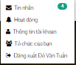

Step 2: Click on “Tổ chức của bạn”. User go to organization detail page, and click on “Sửa thông tin” button. User will go to Edit Organization page:  
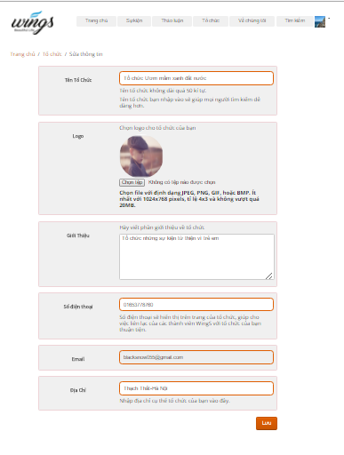

1. Edit Organization screen

Step 3: Enter information and click on “Lưu” button.

## Donate Event

This is the most importance feature. To use this fearture user do the steps below:

Step 1: From event details page, click on “Quyên góp” link. System go to donate project page.

Step 2: Choose payment methods, numbers of money , enter content and click on “Thanh toán” button. System go to the Ngân lượng and backer complete some of step in Ngân lượng to donate success event.

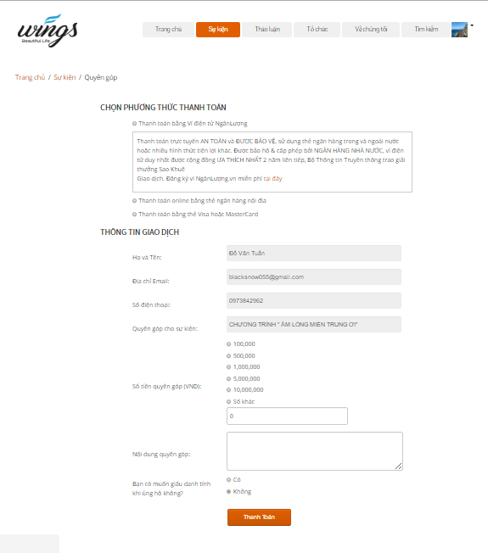

1. Donate event screen

## Message

In this page user can view messages to create new message, view message.

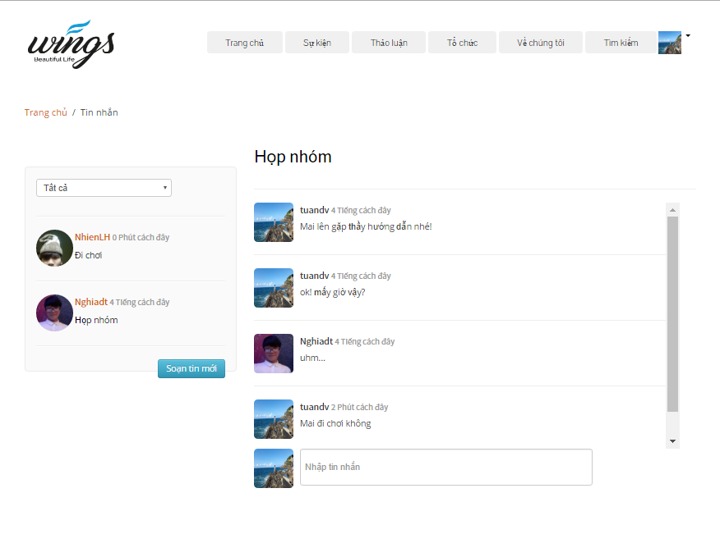

1. Message screen

### Sent message

To sent message user do the steps below:

Step 1: Click on avatar in header, then click on “Tin nhắn” link. System go to message page.

Step 2: Click on “Soạn tin nhắn” button.

Step 3: Enter information and click sent button.

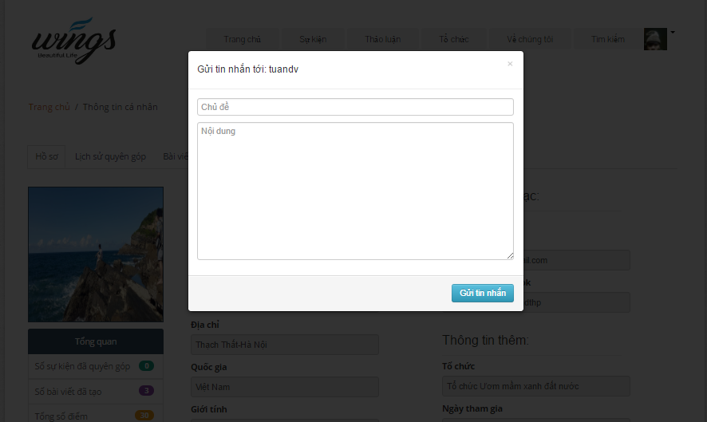

1. Sent message

### Message view

In this page, user can sent and receive message create a conversation. To view conversation user do the steps below:

Step 1: Click on avatar in header, then click on “Tin nhắn” link. System go to message page.

Step 2: Click on a message to view conversation.

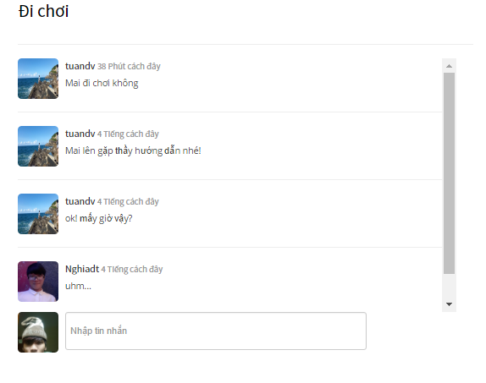

1. Message view screen

## Account management

### Change password

To change password user do the steps below:

Step 1: Click on avatar in header, then click on “Thông tin tài khoản” button. System will go to account detail page.

Step 2: Click on “Đổi mật khẩu” tab

Step 3: Enter username, old pass, new pass, confirm new pass.

Step 4: Click “Đổi mật khẩu” button.

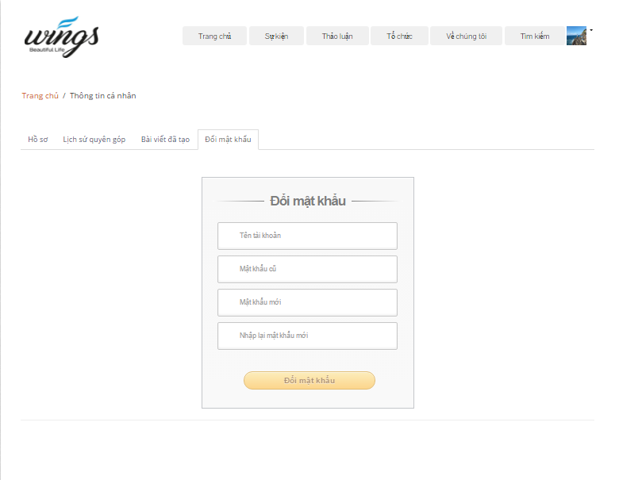

1. Change pass screen

### Public profile

User can view public profile.

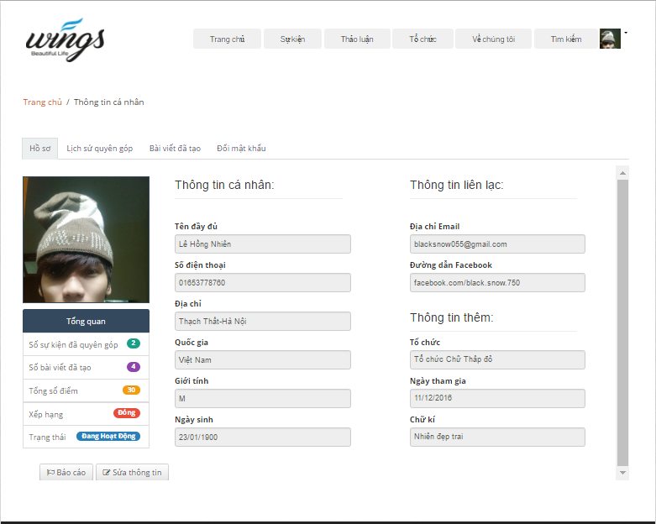

1. Public profile screen

### Donated history

User can view donate history.

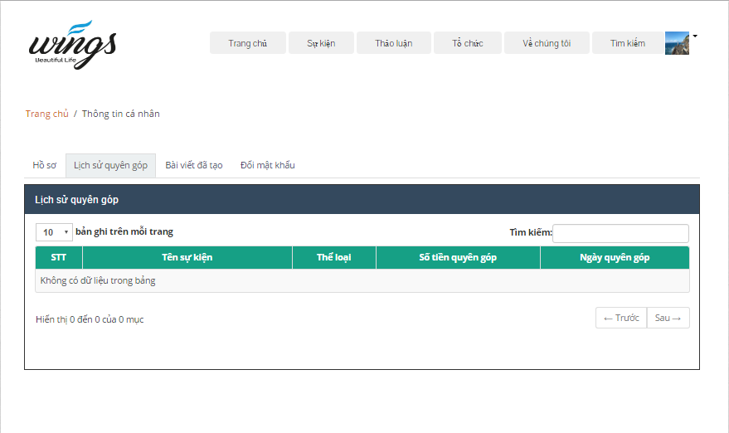

1. Donated history

### Created thread

User can view created thread.

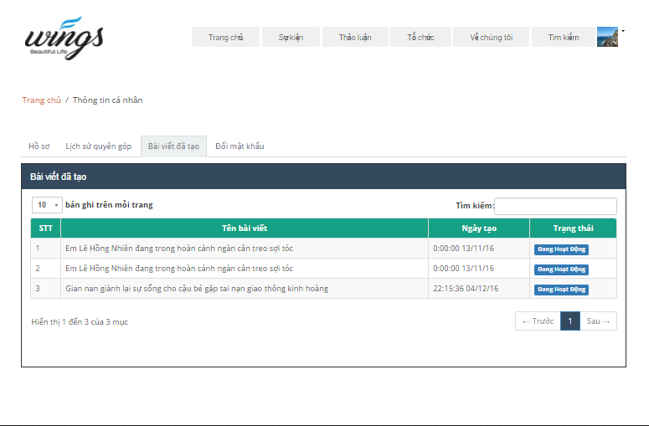

1. Created thread

### Edit profile

To change info of user do the steps below:

Step 1: Click on avatar in header, then click on “Thông tin tài khoản” link. System will go to account detail page.

Step 2: Click on “Sửa thông tin” button

Step 3: Enter information.

Step 4: Click “Lưu” button.

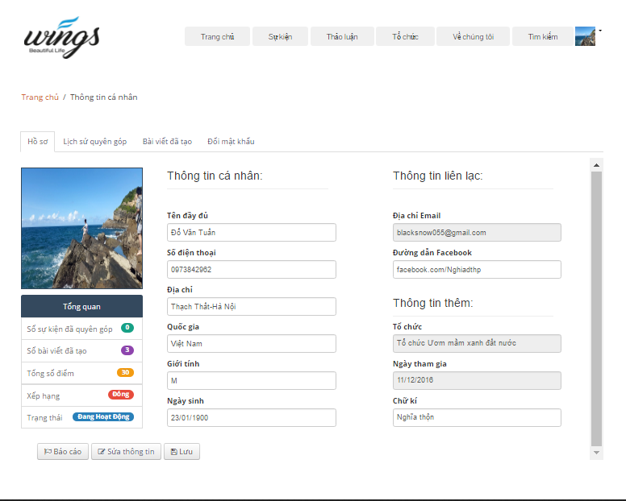

1. Edit profile screen

## ADMIN

### Login

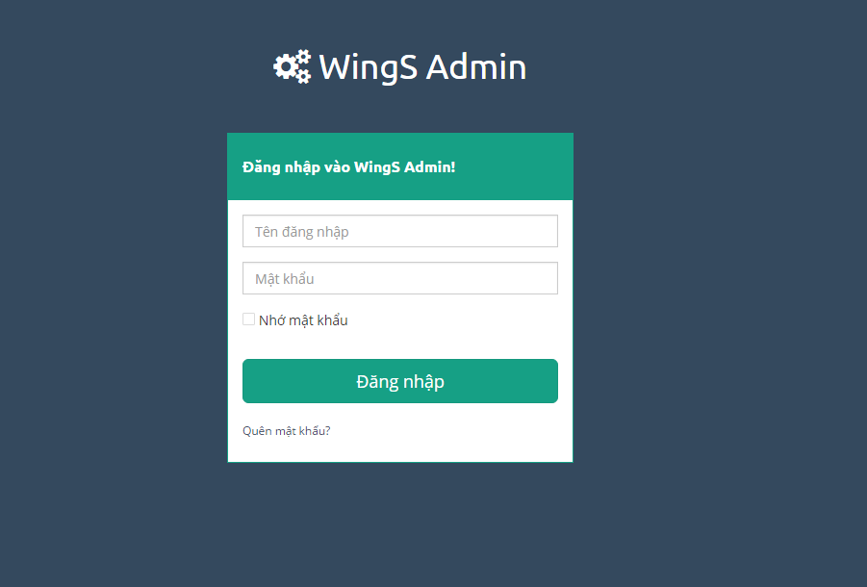

1. Login screen

To login admin account, the users do the steps below:

Step 1: Open browser and enter to the address bar: <http://wings.com/admin/>.

Step 2: User enter username and password

Step 3: Click on “Đăng nhập” button

### Dashboard

At this page, Admin can view overview about user, organization, thread, event.

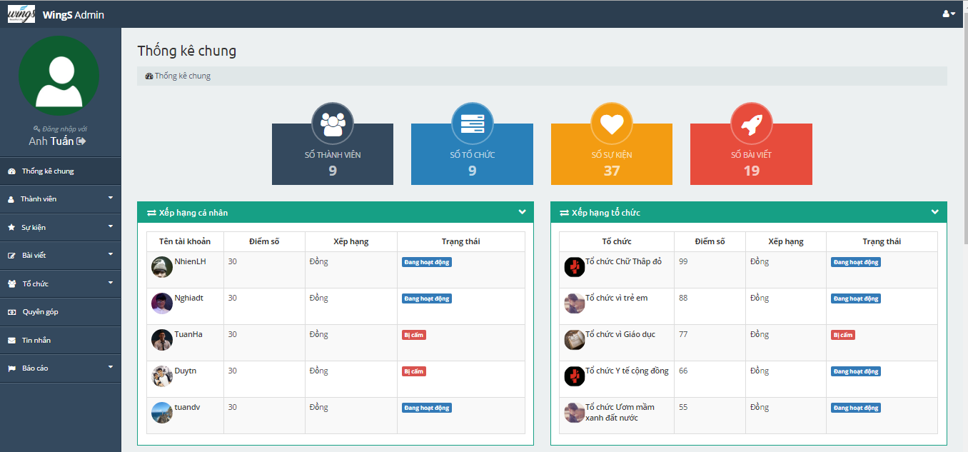

1. Dashboard 1

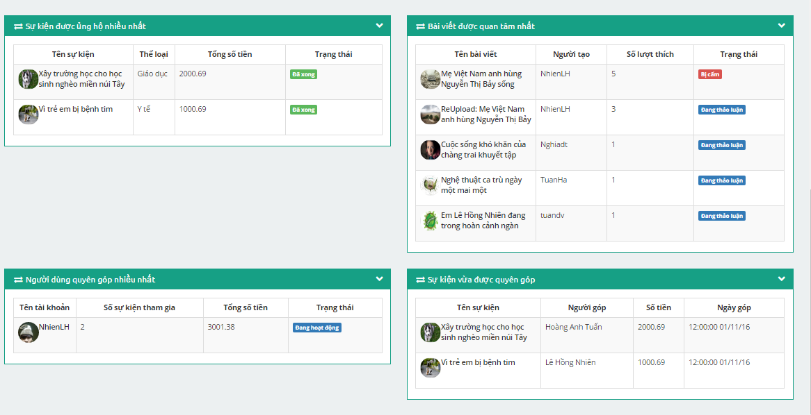

1. Dash board 2

### Users

To lock/unlock a account. Admin do the step below:

Step 1: Go to Admin page, Click on “Thành viên -> Danh sách thành viên” link. System return list account.

Step 2: Choose account and click on “Trạng thái” column to lock/unlock account.

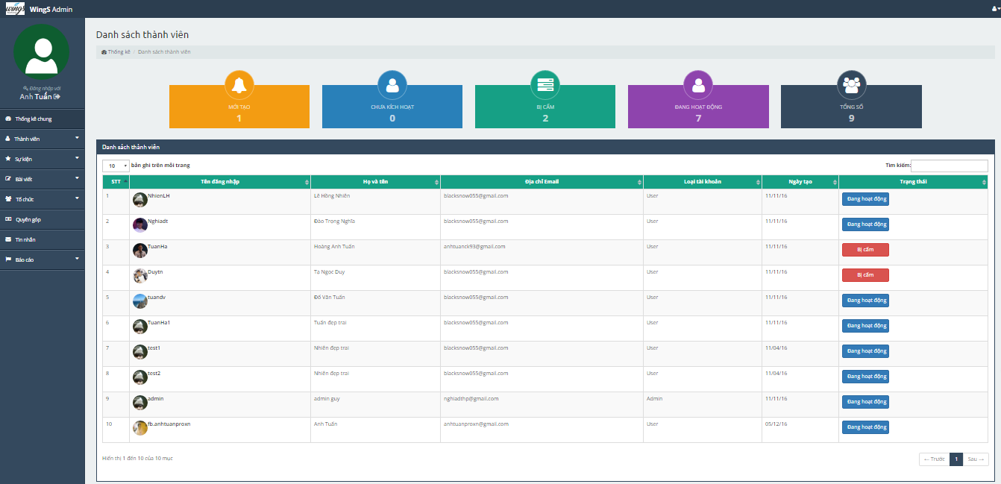

1. Users list screen

### Event

To lock/unlock event. Admin do the step below:

Step 1: Go to Admin page, Click on “Sự kiện -> Danh sách sự kiện”. System returns list event.

Step 2: Choose event and click on “Trạng thái” column to lock/unlock event when status of event is : “Đang diễn ra” or “Bị cấm”. System go to project detail page.

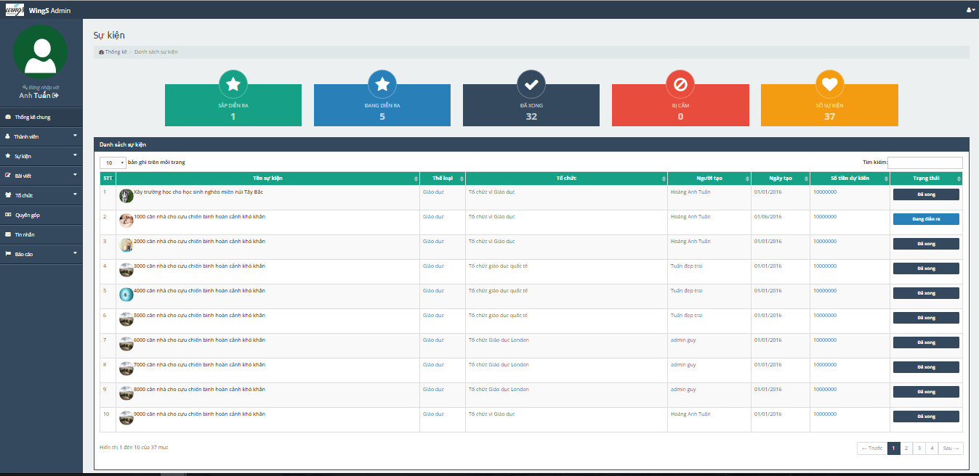

1. Projects list screen

#### Add event type

Admin can add new event type or lock/unlock event type.

Adding new event type, admin do the step below:

Step 1: Go to Admin page, Click on “Sự kiện -> Thể loại sự kiện”. System returns event type page.

Step 2: Click on “Thêm thể loại” button in header. Dialog event type will display:  
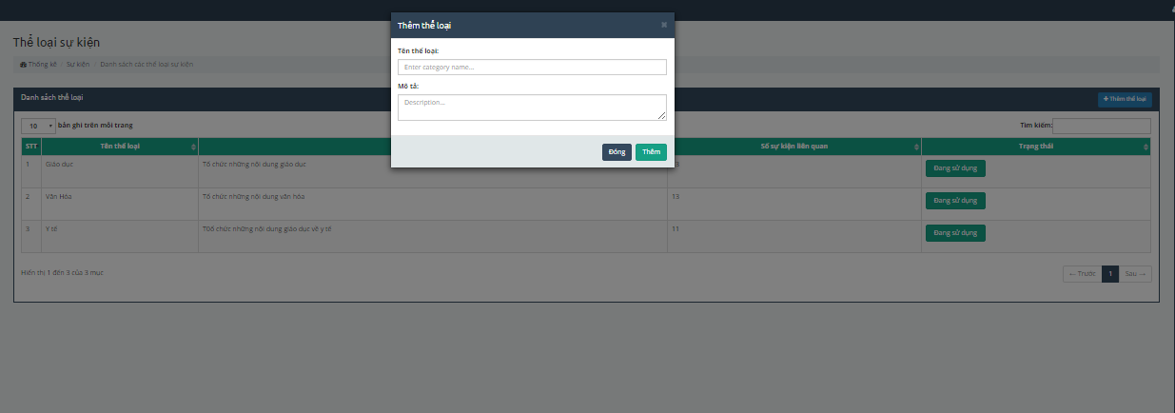

**Fi**

Step 3: Enter information, and click “Thêm” button to add.

Lock/unlock event type, admin do the step below:

Step 1: Go to Admin page, Click on “Sự kiện -> Thể loại sự kiện”. System returns event type page.

Step 2: Choose event type and click on “Trạng thái” column to lock/unlock event type.

### Thread

To lock/unlock a thread. Admin do the step below:

Step 1: Go to Admin page, Click on “Bài viết -> Danh sách bài viết” link. System return list thread.

Step 2: Choose thread and click on “Trạng thái” column to lock/unlock account.

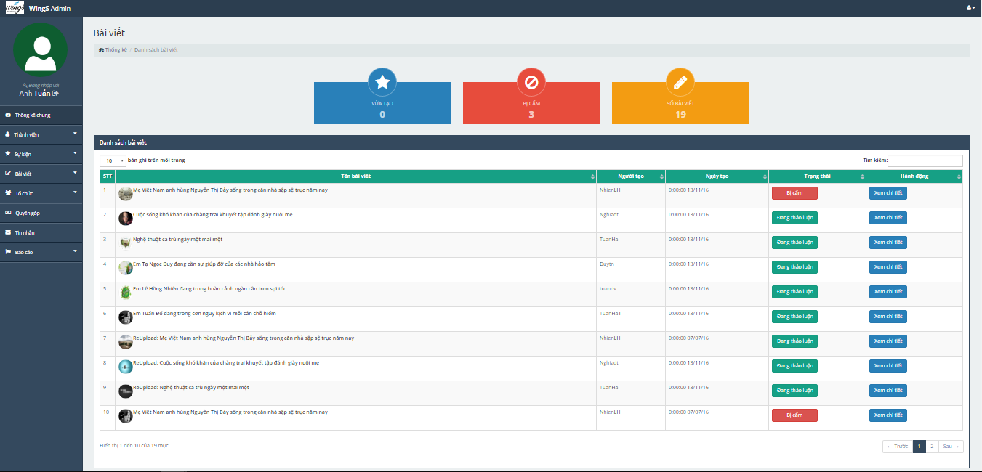

1. Thread list screen

### Organization

#### Organization register list

To accept/refuse a request create an organization from user. Admin do the step below:

Step 1: Go to Admin page, Click on “Tổ chức -> Danh sách đăng ký” link. System return organization register list.

Step 2: Choose organizarion and click on “Đồng ý” or “Từ chối” button to accept/refuse organizarion.

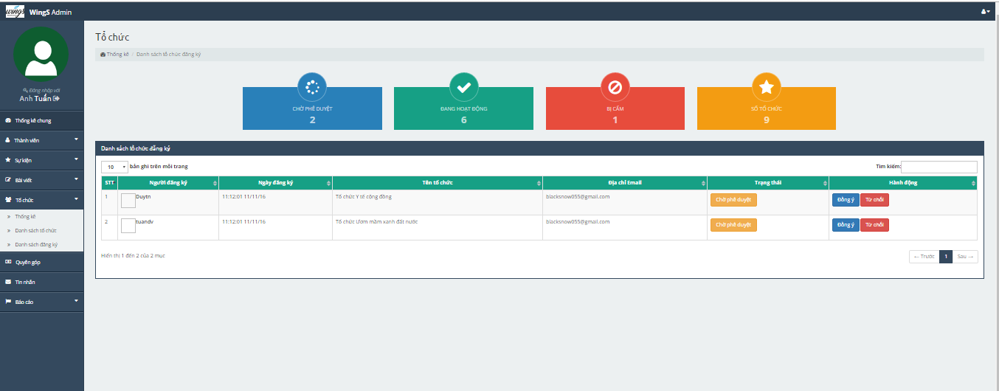

1. Organization register list

#### Organization list

To lock/unlock a organization. Admin do the step below:

Step 1: Go to Admin page, Click on “Tổ chức -> Danh sách tổ chức” link. System return list organization.

Step 2: Choose organization and click on “Trạng thái” column to lock/unlock organization.

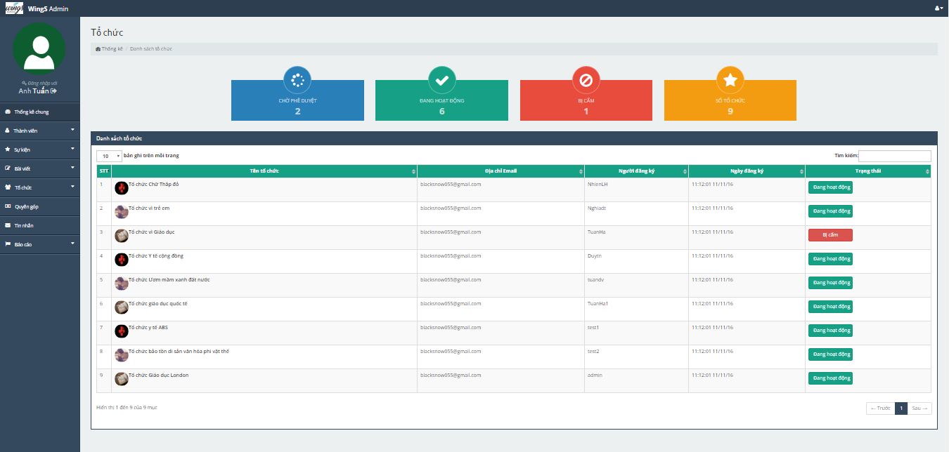

1. Organization list screen

### Backing

Admin can manage list banker.

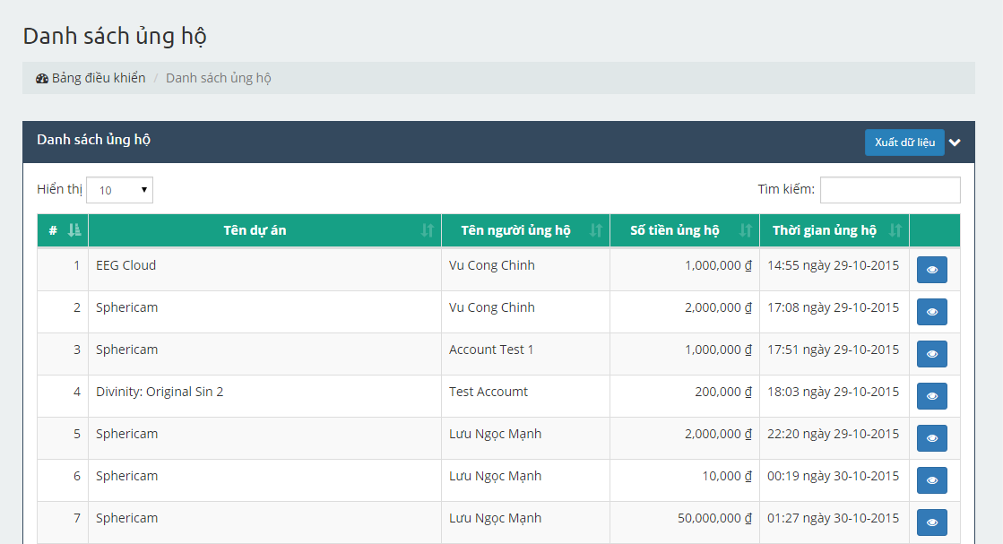

1. Backing list screen

### Message (same as message of user)

Admin can manage message. (Create sent, receive, delete message)

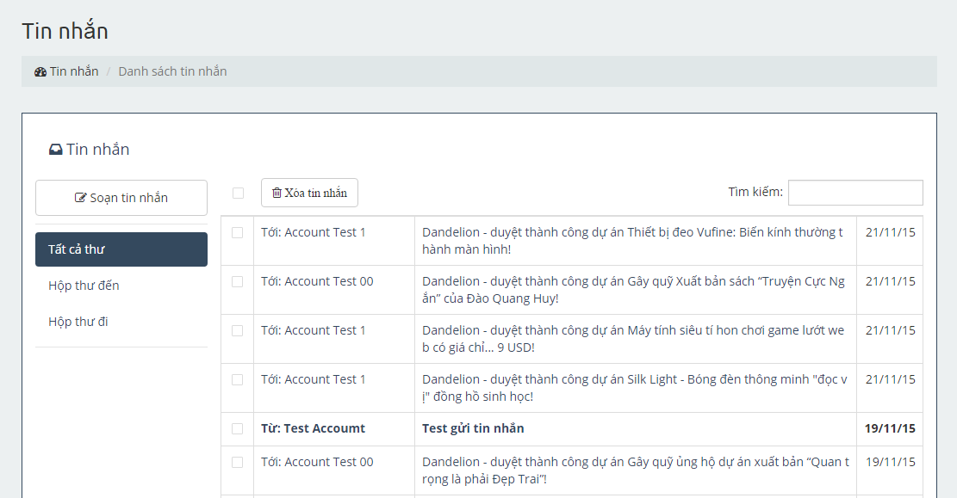

1. Message screen

### Report

#### Report user

Step 1: Click on Báo cáo người dung

Step 2: Choose user to report

Step 3: Click on Accept/Reject

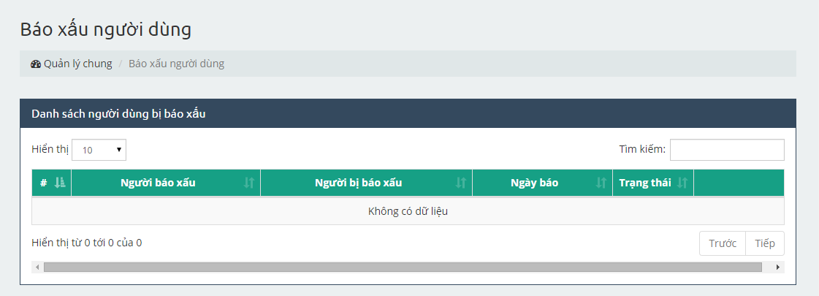

1. Report user management screen

#### Report project

Step 1: Click on Báo cáo dự án

Step 2: Choose project to report

Step 3: Click on Accept/Reject

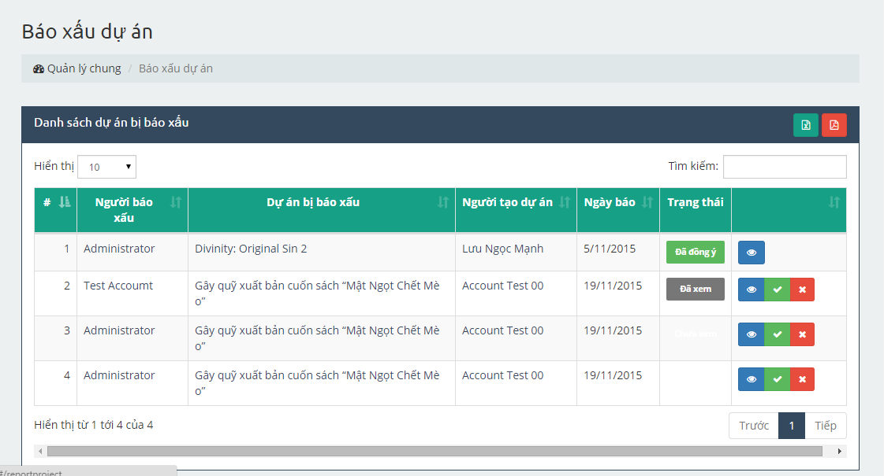

1. Report project management screen